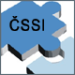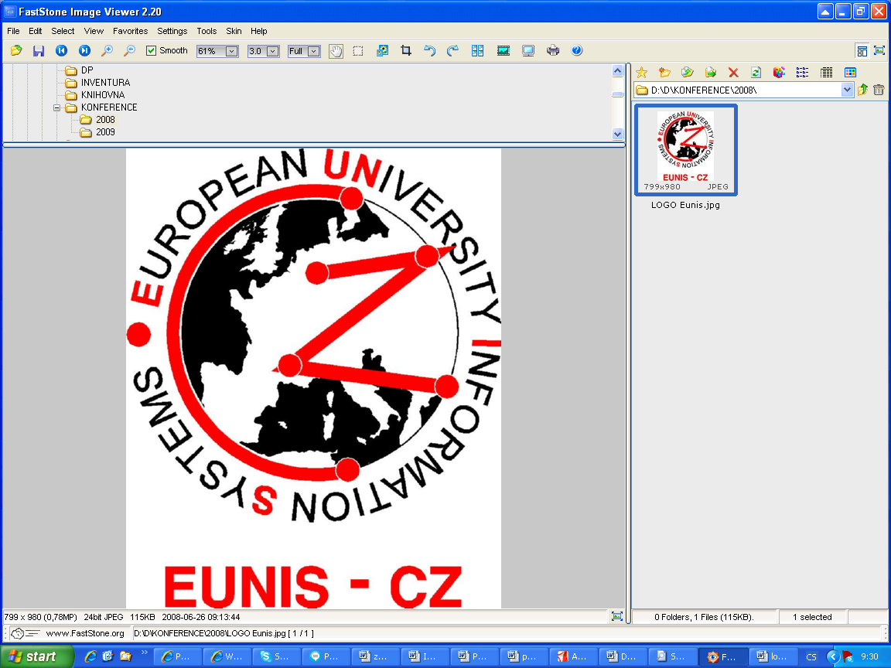

VSB – Technical University Ostrava, Faculty of Economics
Czech Society for System Integration
Moravian-Silesian Section
EUNIS-CZ
In collaboration with Karel Engliš Foundation
organize
18th International conference on

Information Technology for Practice 2015

8th – 9th October 2015

Thematic focus: | IT Management  Information Society and Trends in IT Education  Information Security  Process Management and its IT Support
Expert guarantors: | Milena Tvrdíková, VŠB-TU Ostrava, Faculty of Economics  Petr Doucek, University of Economics, Prague  Jan Ministr, VŠB-TUO, Faculty of Economics
Venue: | Faculty of Economics VSB-TUO, Havlíčkovo nábřeží 38, Ostrava
Contact person: | Jana Elisová, tel: +420 597 322 413, jana.elisova@vsb.cz
Information and  registration | http://www.cssi-morava.cz
Important dates: | Registration of participants with the titles and abstracts of contribution |  | August 31, 2015
 | Notification of title and abstract acceptance: |  | September 2, 2015
 | Full papers from regular authors due: |  | September 6, 2015
 | Notification of acceptance: |  | September 13, 2015
 | Sending of final paper: |  | September 20, 2015
 | Possibility of exposure to Advertising: |  | September 30, 2015
 | Registration of participant without paper: |  | September 30, 2015
Conference fee: | Regular participant  Members of ČSSI  Doctoral participant | Paid before Paid after  September 18, 2015  1.800,-Kč or 70 EUR 2.000,-Kč or 80 EUR  1.300,-Kč or 50 EUR 1.500,-Kč or 60 EUR  600,-Kč or 25 EUR 600,-Kč or 25 EUR
 | Publication of the paper in the proceedings only 600,-Kč or 25 EUR

All submitted papers will be reviewed. On review are involved members of the program Committee.
All accepted papers will be published on Web of conference.
In the printed conference proceedings will be published only papers written in English
Participants will receive proceedings at registration.
In case of absence a conference fee will not be returned. Proceedings will be sent by post.

